“Design and Development of DOCEASE – A Hospital Appointment Booking System”
A Project Report Submitted in the partial fulfilment of the requirements for the award of the degree of
BACHELOR OF TECHNOLOGY
In
DEPARTMENT OF COMPUTER SCIENCE ENGINEERING
By
MALAVARAPU BALA PRANITHA : 2520030051
MUDDANAGIRI DURGA SAI MANASA : 2520030500
Under the Esteemed Guidance of
Ms. K. MADHAVI


K L (Deemed to be) University
DEPARTMENT OF COMPUTER SCIENCE ENGINEERING


Declaration
The Project Report entitled “Design and Development of DOCEASE – A Hospital Appointment Booking System” is a record of bonafide work carried out by MALAVARAPU BALA PRANITHA – 2520030051 and MUDDANAGIRI DURGA SAI MANASA – 2520030500, submitted in partial fulfilment for the award of B.Tech in Computer Science and Engineering (or) Computer Science and Information Technology at K L (Deemed to be) University. The results embodied in this report have not been copied from any other department/University/Institute.

MALAVARAPU BALA PRANITHA – 2520030051
MUDDANAGIRI DURGA SAI MANASA – 2520030500
K L (Deemed to be) University
DEPARTMENT OF COMPUTER SCIENCE ENGINEERING


Certificate
This is to certify that the mini project based report entitled “Design and Development of DOCEASE – A Hospital Appointment Booking System” is a bonafide work done and submitted by MALAVARAPU BALA PRANITHA – 2520030051 and MUDDANAGIRI DURGA SAI MANASA – 2520030500 in partial fulfilment of the requirements for the award of the degree of BACHELOR OF TECHNOLOGY in the Department of Computer Science Engineering, K L (Deemed to be) University, during the academic year 2025–2026.

Signature of the Guide (Ms. K. Madhavi)
Signature of the Course Coordinator
Signature of the HOD

Acknowledgement
The success of this project would not have been possible without the timely help and guidance extended by many people. We wish to express our sincere thanks to everyone who assisted us, in one way or another, towards the completion of this project.
Our greatest appreciation goes to our esteemed guide, Ms. K. Madhavi, Assistant Professor, Department of Computer Science, whose tremendous support, encouragement and technical guidance made this project possible. Her constant feedback at every stage of development helped us shape DOCEASE into a complete and functional hospital appointment booking platform.
We also express our gratitude to the Head of the Department of Computer Science Engineering / Computer Science and Information Technology for providing us with adequate facilities, resources and an encouraging environment in which to carry out this project-based lab work.
We thank all the members of the teaching and non-teaching staff who assisted us directly or indirectly in the successful completion of this project. Finally, we sincerely thank our parents, friends and classmates for their kind help, patience and cooperation throughout the duration of this work.

MALAVARAPU BALA PRANITHA – 2520030051
MUDDANAGIRI DURGA SAI MANASA – 2520030500

Abstract
Healthcare access continues to be hindered by inefficient, manual appointment scheduling processes that rely on long waiting queues, telephone calls and paper-based registers. Patients frequently experience long waiting times, double-bookings and a complete lack of visibility into doctor availability, while hospital staff struggle to coordinate schedules across multiple departments and doctors. To address these inefficiencies, this project presents DOCEASE, a web-based Doctor Appointment Booking System designed to digitise and simplify the entire appointment lifecycle for patients, doctors and hospital administrators.
DOCEASE is structured around three clearly separated user roles — Patient (User), Doctor and Admin — each accessing a dedicated dashboard tailored to their responsibilities. Patients can browse doctor profiles across departments such as Cardiology, Neurology, Orthopedics, Pediatrics and Dermatology, book appointments by selecting a department, doctor, date and time slot, and track the status of their bookings (Confirmed, Completed or Cancelled) through a personal appointment history. Doctors are provided with a dashboard that lists their day-to-day appointments and allows them to mark each appointment as Completed or Cancelled, automatically generating patient notifications for cancellations. Administrators are given complete control over the hospital's operational data through dedicated modules for Doctor Management (adding departments and doctors), Appointment Management and Patient Records, including the ability to search records and export them as CSV files.
The system has been implemented using React.js for the user interface, with component-based architecture, state management through React Hooks, and client-side persistence achieved through the browser's localStorage API, allowing appointment, doctor and notification data to remain available across sessions without requiring a dedicated backend server during this phase of development. The application is fully responsive, visually consistent across the Home, Patient Dashboard, Doctor Dashboard and Admin Dashboard views, and demonstrates sound principles of modular front-end engineering, role-based access control, and user-centred design.
In summary, DOCEASE delivers a complete, reliable and user-friendly digital solution that significantly improves the experience of booking, managing and tracking hospital appointments, while laying a scalable foundation for future integration with a full backend, database and notification infrastructure.

Index
Ch. | Topic | Page
 | Acknowledgement
 | Abstract
1 | Introduction (Background, Problem Statement, Scope, Objectives, Importance, Target Users) | 5–15
2 | System Requirements (Hardware, Software, Dev Tools & Frameworks) | 16–21
3 | Technology Stack (Front-end, Back-end, Database, Version Control, APIs) | 22–32
4 | System Architecture (High-level diagram, Layers, Deployment) | 33–36
5 | Design (Use-case flow, ER Diagram / Data Schema) | 37
6 | Implementation (Modules, Front-end logic, Data Integration, Auth) | 38–47
7 | Features (List of features, How each feature works) | 48–55
8 | Testing (Manual/Functional, Integration, Tools, Test cases) | 56–64
9 | Deployment (Steps, Environment Configuration, Hosting) | 65–73
10 | Challenges & Limitations (Issues, Solutions, Known Bugs) | 74–82
11 | Future Enhancements (Planned Features, Integrations) | 83–88
12 | Conclusion (Summary, Achievements, Skills Learned) | 89–97
13 | References | 98–99
14 | Appendices (Screenshots, Code Snippets, Setup, User Manual, Geo-Tag Photos) | 100+

CHAPTER 1 – INTRODUCTION

1.1 Background of the Project
Healthcare delivery depends heavily on the efficient coordination of time between patients and doctors. In most small and mid-sized hospitals or clinics, appointment scheduling is still managed manually — patients walk in, stand in queues, or call the reception desk to check doctor availability. This traditional approach is slow, error-prone and frustrating for both patients and staff, particularly during peak hours when multiple patients attempt to consult the same doctor.
The continual advancement of web technologies has made it possible to digitise such processes through simple, accessible online platforms. The proposed system, DOCEASE, emerged from the observation that even a lightweight, well-designed web application can eliminate much of the friction associated with appointment scheduling. Rather than depending on phone calls or physical registers, patients can log in, view doctor profiles across departments, check available time slots and confirm a booking within a few clicks.
The project draws upon core principles of web application development — component-based UI design, role-based dashboards, and client-side state persistence — to produce a working prototype that mirrors the structure of a real hospital management system while remaining simple enough to be developed, demonstrated and maintained as an academic project. The system is divided into three clear actors: the Patient, who books and tracks appointments; the Doctor, who manages a daily appointment list; and the Admin, who manages departments, doctors and the master record of all patients.
From an academic and engineering perspective, the background of this project draws upon several core areas of computer science: front-end web development using React.js, state and data management using browser storage, user interface and user experience design, and the application of role-based access control to separate the concerns of different user types within a single shared codebase.

1.2 Problem Statement
In many small clinics and hospitals, the process of booking, tracking and managing patient appointments remains manual and fragmented. Patients often have no visibility into which time slots are available for a given doctor, leading to overcrowded waiting rooms, missed appointments and avoidable confusion. Doctors, in turn, have no centralised way of viewing their day's schedule or updating the status of an appointment once it is completed or cancelled.
Administrators face an even greater challenge: maintaining an accurate, searchable record of every doctor, every department and every patient interaction typically requires either expensive hospital management software or error-prone spreadsheets and paper files. There is no simple, lightweight tool that allows a small hospital to add departments and doctors, track all appointments across the institution and export patient records for reporting — all from a single, easy-to-use interface.
The core problem this project addresses is therefore the absence of an integrated, role-aware booking system that is simple enough for a small clinic to adopt immediately, yet structured enough to reflect the operational reality of a hospital: multiple departments, multiple doctors per department, individual doctor schedules, and a central administrative view of all activity. DOCEASE was conceived specifically to close this gap.

1.3 Scope of the Project
The scope of DOCEASE covers the complete appointment lifecycle for a small-to-medium hospital: patient registration and login, browsing of doctor profiles by department, booking of appointments against specific doctors, dates and time slots, tracking of appointment status, doctor-side management of daily appointments, and administrator-side management of departments, doctors and patient records.
The technical scope involves building a fully responsive, component-driven web application using React.js that functions consistently across desktop and mobile browsers. The current implementation persists data using the browser's localStorage mechanism, which is sufficient for demonstration, single-device usage and academic evaluation. The architecture has nonetheless been designed in a modular fashion so that the localStorage layer can later be replaced with calls to a real backend API and a relational database without requiring a redesign of the user interface.
Excluded from the current scope are real-time multi-device synchronisation (since data is stored per-browser rather than on a shared server), SMS/email-based notifications, online payment for consultation fees, and integration with real hospital information systems. These items are identified separately in Chapter 11 as planned future enhancements.

1.4 Objective(s)
- To design and develop a unified web-based platform that allows patients to book, view and cancel hospital appointments without manual intervention.
- To provide doctors with a dedicated dashboard that lists their daily appointments and allows them to update appointment status (Complete / Cancel).
- To provide hospital administrators with full control over departments, doctors and patient records through a single Admin Dashboard.
- To implement a responsive, accessible and visually consistent user interface across all three user roles.
- To maintain appointment, doctor and notification data reliably across sessions using browser-based persistence.
- To structure the codebase in a modular, component-based fashion that can be extended with a real backend and database in future iterations.
- To demonstrate, through a working prototype, the practical application of front-end engineering, state management and role-based design principles.

1.5 Importance of the Application
The importance of DOCEASE lies in its ability to consolidate the entire appointment management process — booking, doctor scheduling and administrative oversight — into a single, coherent digital platform. For patients, the system removes the uncertainty of walking into a hospital without knowing whether a doctor is available, replacing it with a transparent booking flow that shows departments, doctors, consultation fees, experience and ratings before a booking is confirmed.
For doctors, the platform offers a simple, distraction-free way to view the day's appointments and update their outcomes, reducing the administrative burden that would otherwise fall on support staff. For hospital administrators, DOCEASE centralises the management of departments and doctors, and provides a searchable, exportable record of every patient interaction — a feature that is invaluable for audits, reporting and day-to-day operational decisions.
From a technological standpoint, the project demonstrates how a relatively small, well-structured React.js application can replicate the core workflows of a much larger hospital management system, making it a valuable reference for students and developers seeking to understand role-based application design, state management and component reuse.

1.6 Target Users / Audience
- Patients seeking a simple way to discover doctors by department and book appointments without visiting the hospital in person.
- Doctors who need a lightweight dashboard to review their daily patient list and update appointment outcomes.
- Hospital administrators responsible for maintaining department and doctor records, monitoring appointments and generating patient reports.
- Small clinics and nursing homes that cannot afford full-scale hospital management software but need a structured booking workflow.
- Students and developers studying role-based web application design as a reference implementation.

CHAPTER 2 – SYSTEM REQUIREMENTS

2.1 Hardware Requirements
Since DOCEASE is a browser-based web application built with React.js, its hardware requirements are modest for both developers and end users. On the development side, a processor equivalent to an Intel Core i3/i5 or AMD Ryzen 3/5, 8 GB of RAM (16 GB recommended when running multiple browser tabs, the React development server and a code editor simultaneously) and at least 5 GB of free disk space for the project's node_modules and build artefacts are recommended. A solid-state drive (SSD) is preferred to keep package installation and hot-reload times low.
A stable broadband connection of at least 5 Mbps is sufficient during development, primarily for installing npm packages and pushing changes to GitHub. For end users, the requirements are minimal: any modern desktop, laptop, tablet or smartphone with a current version of Google Chrome, Microsoft Edge, Firefox or Safari is capable of running the application smoothly, since all logic executes client-side and no specialised hardware acceleration is required.
A Full HD display (1920×1080 or higher) is recommended for development and UI testing to ensure that dashboard layouts, tables and cards render correctly before verifying responsiveness on smaller screen sizes.

2.2 Software Requirements
The development environment is built around Node.js (v18 LTS or later) and the npm package manager, which together provide the JavaScript runtime and dependency management needed to run and build the React application. Visual Studio Code is used as the primary code editor, offering syntax highlighting, integrated terminal access and Git integration.
The front-end is built entirely with React.js (using functional components and React Hooks such as useState), plain CSS for styling, and modern JavaScript (ES6+). Data persistence for the current prototype is handled through the browser's built-in localStorage API, which removes the need for a separate database server during development and demonstration. Git is used for version control, with GitHub serving as the remote repository for collaboration and backup.
Any modern operating system — Windows 10/11, macOS or Ubuntu Linux — is suitable for development. For testing, an up-to-date browser (Chrome, Edge or Firefox) with developer tools enabled is used to inspect component state, verify localStorage entries and test responsive layouts across device emulation profiles.

2.3 Development Tools and Frameworks
Category | Tool / Technology
Front-end Library | React.js (functional components, Hooks)
Styling | Plain CSS3 (component-level stylesheets)
Language | JavaScript (ES6+), JSX
Data Persistence | Browser localStorage (JSON-serialised records)
Package Manager | npm
IDE | Visual Studio Code
Version Control | Git & GitHub
Browser Testing | Chrome / Edge / Firefox DevTools
Build Tooling | Create React App (react-scripts)
Each of these tools was selected for its accessibility, strong community support and suitability for a project of this scale. React's component model in particular made it straightforward to keep the Patient, Doctor and Admin dashboards visually and structurally consistent while still isolating their individual logic into separate files such as PatientDashboard.jsx, DoctorDashboard.jsx and AdminDashboard.jsx.

CHAPTER 3 – TECHNOLOGY STACK

3.1 Front-End
The front-end of DOCEASE is built entirely using React.js, with the application's structure organised into clearly separated components: App.jsx (the root component that manages routing-like state and renders the Home, Login, Signup and role-specific dashboards), PatientDashboard.jsx, DoctorDashboard.jsx, AdminDashboard.jsx, AppointmentBooking.jsx, DoctorProfiles.jsx, DoctorManagement.jsx, AppointmentManagement.jsx, AppointmentHistory.jsx, PatientRecords.jsx, MyAppointments.js and PaymentPage.jsx.
React's useState Hook is used extensively to manage local component state — for example, showLogin, role, showAdminDashboard, showBooking and showDoctorDashboard in App.jsx control which view is rendered at any given time, effectively implementing a lightweight, state-driven navigation system without a dedicated router library. Conditional rendering (if (showBooking) return <PatientDashboard />;) is used throughout to switch between the Home page, login/signup forms and the three role-specific dashboards.
Plain CSS (App.css, index.css) is used for styling, giving the interface a clean, card-based visual language: rounded white panels over soft background imagery (hospital.jpg, patient-bg.jpg), blue/purple/green accent buttons for the User, Doctor and Admin entry points respectively, and consistent table styling for appointment and patient-record listings. Emoji icons (🏥, 📅, 📝, 🔔) are used throughout the dashboards to give the interface a friendly, approachable character without requiring an icon library.
The interface is responsive by design — cards and forms reflow naturally on smaller screens, and tables scroll horizontally where necessary — ensuring that the Home page, booking form, doctor profile grid and admin tables remain usable across desktop, tablet and mobile viewports.

3.2 Back-End
In the current phase of development, DOCEASE does not run a separate server-side application; instead, the “business logic” that would traditionally live in a back-end (validating bookings, updating appointment status, generating notifications) is implemented directly within React components, operating on data read from and written back to localStorage. For instance, the updateStatus function inside DoctorDashboard.jsx reads the current appointments array, updates the relevant entry's status field, persists the updated array back to localStorage, and — when an appointment is cancelled — pushes a new entry into a notifications array so the corresponding patient is informed.
This approach was deliberately chosen for the academic prototype because it allows the complete booking, doctor-management and admin workflows to be demonstrated end-to-end without requiring server infrastructure, hosting costs, or network dependency during evaluation. The component structure has, however, been designed so that each localStorage read/write can be swapped for an equivalent HTTP call to a REST API with minimal change to the surrounding component logic — this migration path is discussed further in Chapter 11 (Future Enhancements), where a Node.js/Express back-end is proposed as the next development milestone.

3.3 Database
The current data layer is the browser's localStorage, which stores structured JSON records under well-defined keys such as appointments, doctors, departments, notifications and loggedInDoctor. Each appointment record contains fields including a generated ID (e.g., DOC5536), patientName, doctor, department, date, time and status (Confirmed, Completed or Cancelled), mirroring the structure of a relational “Appointments” table. Doctor records similarly contain name, department, experience, fee and availability fields, equivalent to a “Doctors” table.
While localStorage is inherently per-browser and does not support multi-user concurrency or relational querying, it was selected for this stage because it requires zero configuration, persists data across page refreshes and browser restarts on the same device, and is sufficient to demonstrate every workflow — booking, doctor updates, admin management and CSV export — in a classroom or demonstration setting. The data model has been kept normalised in spirit (appointments reference doctors and departments by name, and patient records are derived by joining appointment entries), so that a future migration to MySQL or MongoDB would require only a change in the data-access layer rather than a redesign of the application's logic.

3.4 Version Control
Git is used as the version control system for DOCEASE, with the project repository hosted on GitHub. The repository is organised with a clear src/ folder containing all React components, the application's static assets (hospital.jpg, male-doctor.png, female-doctor.png, logo.svg) and configuration files such as App.test.js and setupTests.js generated by Create React App.
Throughout development, the project followed a simple branching discipline: feature work for each dashboard (Patient, Doctor, Admin) was developed in isolation and merged once tested, with descriptive commit messages used to track the addition of components such as AppointmentManagement.jsx and PatientRecords.jsx. A .gitignore file excludes the node_modules folder and any local build artefacts from version control, keeping the repository lightweight and focused purely on source code.

3.5 APIs or External Services
The present version of DOCEASE does not depend on any external third-party APIs; all doctor, department and appointment data is generated and stored locally within the application itself, which keeps the system fully self-contained and demonstrable without internet connectivity or API keys.
The architecture has nonetheless been planned with future API integration in mind. Planned external integrations — discussed in greater depth in Chapter 11 — include SMS/email notification services (for appointment reminders), a payment gateway such as Razorpay or Stripe (a placeholder PaymentPage.jsx component already exists in the codebase) and, eventually, a dedicated REST API backed by a relational database to replace the current localStorage layer.

CHAPTER 4 – SYSTEM ARCHITECTURE

4.1 High-Level Architecture Diagram
The architecture of DOCEASE follows a simple, three-tier conceptual model adapted for a client-only prototype:
- Presentation Layer – React.js components rendering the Home page and the Patient, Doctor and Admin dashboards.
- Application / State Layer – React Hooks (useState) and component functions that implement booking, status-update and CRUD logic for departments, doctors and appointments.
- Persistence Layer – the browser's localStorage API, acting as the system's data store for appointments, doctors, departments and notifications.
Data flows in a single direction within each user session: a user action (e.g., clicking “Book Appointment”) triggers a state update in the relevant component, which is immediately written to localStorage and re-rendered on screen — giving the interface its real-time, app-like responsiveness without any network round-trip.

4.2 Description of Each Layer (Frontend, Backend, Database)
The Frontend layer is the visual and interactive face of DOCEASE, built using React.js, HTML5 semantics within JSX, and CSS3 for styling. It is responsible for rendering the Home page (with its User / Doctor / Admin entry cards), the Patient Dashboard (Book Appointment, My Appointments, Notifications, Doctor Profiles), the Doctor Dashboard (Today's Appointments with Complete/Cancel actions) and the Admin Dashboard (Doctor Management, Appointment Management, Patient Records).
The Backend / Application layer, in the current implementation, is embedded within the React components themselves rather than running as an independent server process. Functions such as updateStatus() in DoctorDashboard.jsx and the doctor-addition logic in DoctorManagement.jsx perform the same role a server-side controller would in a traditional three-tier system: validating input, applying business rules (e.g., generating a notification when an appointment is cancelled) and persisting the result.
The Database layer is represented by the browser's localStorage, organised into discrete JSON collections (appointments, doctors, departments, notifications). Although this is not a relational or document database in the traditional sense, it fulfils the same architectural role — durable, structured storage that the application layer reads from and writes to — and is designed to be replaced transparently by a real database once a backend service is introduced.

4.3 Deployment Architecture (Cloud, Local, CI/CD Pipelines)
For development and demonstration, DOCEASE runs locally using the Create React App development server (npm start), which compiles the JSX/ES6 source into a browser-runnable bundle and serves it on localhost with hot-reloading enabled. For a production-style deployment, the standard React build pipeline (npm run build) produces an optimised static bundle of HTML, CSS and JavaScript that can be hosted on any static-hosting platform such as Netlify, Vercel or GitHub Pages, since the application currently has no server-side dependency.
Although a full CI/CD pipeline has not yet been configured for this academic prototype, the codebase has been structured to support one easily: a GitHub Actions workflow could be added to automatically run npm install, npm test and npm run build on every push to the main branch, followed by automatic deployment of the build/ folder to a static host. This is identified as a planned enhancement in Chapter 9 and Chapter 11.

CHAPTER 5 – DESIGN

5.1 Use-Case and Data Flow Overview
DOCEASE supports three primary actors — Patient, Doctor and Admin — each with a distinct set of use cases. The Patient actor can register/log in, browse doctor profiles, book an appointment, view their appointment history and receive cancellation notifications. The Doctor actor can log in, view today's appointments filtered to their own name, and mark each appointment as Completed or Cancelled. The Admin actor can log in using fixed administrator credentials, add departments and doctors, view and manage all appointments across the hospital, and search or export the full patient record list as a CSV file.
The data flow for a typical booking begins when a patient selects a department, doctor, date and time slot on the Appointment Booking form. On submission, a new appointment record (with a generated ID, e.g., DOC5536) is appended to the appointments array in localStorage with an initial status of “Confirmed”. This same array is read by the Doctor Dashboard (filtered to appointments where doctor === loggedInDoctor) and by the Admin's Appointment Management and Patient Records views (unfiltered, showing every patient across every department), ensuring that all three dashboards remain consistent with a single underlying data source.

5.2 ER Diagram / Data Schema
The conceptual entity-relationship structure of DOCEASE, as implemented through its localStorage collections, is summarised below:
Entity | Key Attributes / Relationships
Doctor | name, department, experience, fee, availability — one Doctor belongs to one Department
Department | name — one Department has many Doctors
Appointment | id, patientName, doctor, department, date, time, status — references one Doctor and one Department
Notification | patientName, message, doctor — generated when an Appointment's status changes to Cancelled
Patient (derived) | patientName, department, doctor, date, time, status — derived view used in Patient Records
This schema, although currently realised through flat JSON arrays in localStorage rather than relational tables, mirrors the normalised structure that would be used in a production MySQL or PostgreSQL schema, with Appointment acting as the central transactional entity referencing both Doctor and Department.

CHAPTER 6 – IMPLEMENTATION

6.1 Module-Wise Implementation
The implementation of DOCEASE is organised into clearly bounded modules, each responsible for one part of the hospital appointment workflow, while sharing a single underlying data store. This modular approach mirrors the way a larger hospital management system would be decomposed, while remaining manageable within an academic project timeline.

Home / Landing Module
Implemented in App.jsx (with a HomePageBackup.jsx fallback), this module presents the DOCEASE brand, a short tagline (“Your Health, Our Priority”), three role-entry cards — User, Doctor and Admin — each with an “Access→” button, and an About Us / Contact Us section displaying the hospital's address, phone number and email. A hospital building photograph and three feature highlights (Secure & Safe, Easy Booking, Better Care) reinforce the platform's purpose.

Patient (User) Module
Implemented primarily in PatientDashboard.jsx, AppointmentBooking.jsx, MyAppointments.js, AppointmentHistory.jsx and DoctorProfiles.jsx, this module welcomes the logged-in patient by name and presents four action cards: Book Appointment, My Appointments, Notifications (showing a live count of unread notifications) and Doctor Profiles. The booking form lets the patient enter their name, select a department, select a doctor (filtered by department), choose a date and a time slot, and submit the booking. The resulting appointment immediately appears in a “My Appointments” table showing ID, Doctor, Date, Time, Status and an Action column that allows the patient to cancel a pending booking.

Doctor Module
Implemented in DoctorDashboard.jsx and DoctorLogin.jsx, this module authenticates the doctor and filters the global appointments array down to only those entries where the doctor field matches the logged-in doctor's name (using localStorage.getItem("loggedInDoctor")). Each appointment card displays the patient's name, the date, time and current status, alongside Complete and Cancel buttons. The updateStatus(index, status) function updates the appropriate entry in place, re-persists the full appointments array to localStorage, and — specifically for cancellations — appends a structured notification object so the patient is informed the next time they open their dashboard.

Admin Module
Implemented in AdminDashboard.jsx, DoctorManagement.jsx, AppointmentManagement.jsx and PatientRecords.jsx, this module is the operational control centre of DOCEASE. Doctor Management allows the admin to add new departments (a simple text input feeding a running Departments list, e.g., Cardiology, Neurology, Orthopedics, Pediatrics, Dermatology, ENT, Ophthalmology, Gynecology, Psychiatry, General Medicine) and add new doctors against a selected department, recording their name, experience, consultation fee, availability date/time and status (e.g., Available). A live Doctors List table displays every registered doctor with a Delete action. Appointment Management presents every booking made across the hospital, while Patient Records aggregates the same data into a patient-centric view with a search-by-name field and a one-click Download CSV button for reporting.

6.2 Front-End Logic (UI Rendering and State Management)
State management in DOCEASE is handled entirely through React's built-in useState Hook rather than an external library such as Redux, which keeps the codebase approachable while remaining fully sufficient for an application of this scope. At the top level, App.jsx maintains boolean and string state variables (showLogin, role, showAdminDashboard, showBooking, showDoctorDashboard, loginId, loginPassword, showSignup) that together determine exactly one view is rendered at any time — effectively implementing client-side navigation through conditional return statements rather than a router library.
Within each dashboard, component-local state (for example, the appointments array in DoctorDashboard.jsx, initialised from JSON.parse(localStorage.getItem("appointments")) || []) is read once on mount and kept synchronised with localStorage on every update, ensuring that a page refresh never loses data created during the session. This pattern — read on mount, mutate a local copy, write back immediately — is repeated consistently across DoctorManagement.jsx, AppointmentManagement.jsx and PatientRecords.jsx, giving the application a predictable, easy-to-reason-about data flow despite the absence of a centralised state-management library.
Rendering throughout the dashboards relies on standard array mapping (appointments.map(...)) to generate cards and table rows dynamically from whatever data currently exists in state, so the interface automatically reflects newly added doctors, departments or appointments without any manual DOM manipulation.

6.3 Data Integration (Local Persistence Layer)
Although DOCEASE does not currently call a remote API, its internal “data integration” layer performs an equivalent role: every component that needs appointment, doctor or department data reads from a single shared localStorage key, ensuring that the Patient, Doctor and Admin dashboards always observe the same underlying dataset. For example, a department added through the Admin's Doctor Management screen is immediately available in the Department dropdown of the Patient's Appointment Booking form, and a doctor added by the Admin instantly appears in both the Doctor Profiles grid and the Appointment Booking doctor dropdown, since both read from the same doctors collection.
This design intentionally anticipates a future migration to a real REST API: every localStorage.getItem/setItem call in the codebase is isolated to a small number of well-defined points (largely at the top of each component, inside useEffect-equivalent initialisation and inside the relevant submit/update handlers), so that swapping these calls for fetch() or axios requests to backend endpoints such as /api/appointments or /api/doctors would require only localised changes rather than a structural rewrite.

6.4 Authentication & Authorisation
DOCEASE implements a simplified, role-based authentication scheme appropriate for its current client-only architecture. Administrator access is controlled through fixed credentials defined within App.jsx (an adminCredentials object containing an id and password), which are checked against the values entered on the login form before showAdminDashboard is set to true. Doctor access follows a similar pattern through DoctorLogin.jsx, which checks the entered doctor name/credentials and, on success, stores the doctor's identity under the loggedInDoctor key in localStorage so that DoctorDashboard.jsx can filter appointments accordingly.
Patient access is handled through a lightweight signup/login flow (signupName, signupEmail, signupPassword state in App.jsx) that captures the patient's name for use throughout their dashboard and appointment records. Because all three roles render entirely different dashboard components once authenticated, DOCEASE achieves clear authorisation boundaries at the UI level: a patient never sees the Doctor or Admin dashboards, and vice-versa, even though all three share the same underlying React application and data store.
While this client-side authentication model is appropriate for an academic prototype, Chapter 11 identifies the introduction of a proper backend authentication layer — using hashed passwords and JWT-based sessions — as a key future enhancement once the system moves beyond a single-device demonstration.

CHAPTER 7 – FEATURES

7.1 List of Main Features
- Role-based Home page with dedicated entry points for User, Doctor and Admin.
- Patient appointment booking by department, doctor, date and time slot.
- Patient appointment history with live status tracking (Confirmed / Completed / Cancelled).
- Patient notifications generated automatically when a doctor cancels an appointment.
- Searchable Doctor Profiles directory showing department, experience, education, specialisation, consultation fee and rating.
- Doctor Dashboard showing today's appointments with one-click Complete / Cancel actions.
- Admin Doctor Management — add departments, add doctors, and maintain a live Doctors List with delete capability.
- Admin Appointment Management — a consolidated view of every appointment across the hospital.
- Admin Patient Records — searchable patient list with one-click CSV export for reporting.
- Fully responsive, card-based UI consistent across all dashboards.

7.2 How Each Feature Works

1. Appointment Booking
User Perspective: A patient opens “Book Appointment”, enters their name, selects a department from a dropdown, selects a doctor (filtered to that department), picks a date and a time slot, and clicks “Book Appointment”. The new booking instantly appears at the top of the “My Appointments” table below the form, with status “Confirmed” and an auto-generated ID such as DOC5536.
Technical Description: On submission, the component constructs a new appointment object (id, patientName, doctor, department, date, time, status: “Confirmed”), appends it to the appointments array read from localStorage, writes the updated array back via localStorage.setItem("appointments", JSON.stringify(...)), and re-renders the table from the updated state.

2. Doctor Profiles Directory
User Perspective: Patients can browse a grid of doctor cards — each showing the doctor's name, department, years of experience, educational qualification, area of specialisation, consultation fee and a star rating — to decide which doctor best suits their needs before booking.
Technical Description: DoctorProfiles.jsx reads the doctors collection from localStorage (or a seeded doctorDetails object as used in AppointmentBooking.jsx) and maps each entry to a card component, rendering attributes such as experience and fee directly from the stored record.

3. Doctor Dashboard – Today's Appointments
User Perspective: After logging in, a doctor sees a list of appointment cards showing the patient's name, date, time and status, with Complete and Cancel buttons on each card.
Technical Description: DoctorDashboard.jsx filters the global appointments array to only those where appt.doctor === loggedInDoctor. Clicking Complete or Cancel invokes updateStatus(index, status), which updates that specific entry's status field, persists the full array back to localStorage, and — for cancellations — pushes a notification object (patientName, doctor, message) into the notifications collection so the patient is informed.

4. Admin – Doctor Management
User Perspective: The administrator can type a new department name and click “Add Department” to see it appear instantly in the Departments list; similarly, filling in a doctor's name, department, experience, consultation fee, availability date/time and status, then clicking “Add Doctor”, adds a new row to the Doctors List table with a Delete action.
Technical Description: Both operations follow the same pattern — capture form input via controlled state, validate that required fields are filled, append a new object to the relevant array (departments or doctors), persist to localStorage, and re-render the corresponding list/table from the updated state.

5. Admin – Patient Records & CSV Export
User Perspective: The administrator can search for any patient by name and instantly filter the records table, or click “Download CSV” to export every patient's department, doctor, date, time and status as a spreadsheet-ready file for offline reporting.
Technical Description: PatientRecords.jsx derives its rows directly from the appointments collection (one row per appointment, since each appointment already contains the patient's name and department). The search field filters this array in real time using a case-insensitive string match on patientName. The Download CSV button serialises the currently displayed rows into comma-separated text and triggers a browser download using a Blob and a temporary anchor element.

CHAPTER 8 – TESTING

8.1 Manual & Functional Testing
Because DOCEASE currently operates without a separate backend API, formal API-testing tools such as Postman were not applicable in the traditional sense; instead, functional testing was carried out directly against the running React application using Chrome and Edge DevTools to inspect component state and verify that every localStorage write matched the expected data shape after each user action.
Each user-facing workflow — patient signup and login, appointment booking, doctor login and status updates, admin login, department/doctor addition, and patient-record search/export — was manually exercised multiple times with both valid and intentionally invalid input (e.g., submitting the booking form with no doctor selected, or searching for a patient name that does not exist) to confirm that the interface responded gracefully in every case, either by disabling the submit action, showing an empty result set, or leaving existing data unaffected.

8.2 Integration Testing
Integration testing focused on verifying that the three dashboards remained consistent with one another, since they all read from the same shared localStorage collections. Specific scenarios verified included: a department added in Admin → Doctor Management appearing immediately in the Patient's booking form department dropdown; a doctor added in Admin → Doctor Management appearing in both the Doctor Profiles grid and the Doctor dropdown on the booking form; an appointment booked by a patient appearing correctly filtered on the corresponding Doctor's dashboard; and a cancellation performed by a Doctor producing a visible notification entry and an updated status on the Patient's “My Appointments” table and the Admin's Patient Records view.
These cross-dashboard checks confirmed that the single shared data-store architecture behaves correctly as a de-facto integration layer, even in the absence of a dedicated backend service.

8.3 Tools Used for Testing
Tool | Purpose
Chrome / Edge DevTools | Inspecting component state, console logs and localStorage entries during manual testing
React Developer Tools (browser extension) | Verifying component state, props and re-render behaviour
Manual Cross-Browser Checks | Confirming consistent rendering on Chrome, Edge and Firefox
Responsive Design Mode | Verifying layout on mobile, tablet and desktop breakpoints
Jest / React Testing Library (App.test.js, setupTests.js) | Scaffolded by Create React App for future automated unit tests

8.4 Test Cases and Results
ID | Test Case | Expected Result | Result
TC01 | Book appointment with all fields filled | New entry appears in My Appointments with status Confirmed | Pass
TC02 | Book appointment with missing doctor selection | Submission blocked / no entry created | Pass
TC03 | Doctor marks an appointment as Completed | Status updates to Completed on Doctor and Admin views | Pass
TC04 | Doctor cancels an appointment | Status set to Cancelled; notification created for patient | Pass
TC05 | Admin adds a new department | Department appears in Departments list and booking dropdown | Pass
TC06 | Admin adds a new doctor | Doctor appears in Doctors List and Doctor Profiles grid | Pass
TC07 | Admin deletes a doctor | Doctor removed from Doctors List | Pass
TC08 | Search patient records by name | Table filters to matching patients only | Pass
TC09 | Download patient records as CSV | Browser downloads a correctly formatted .csv file | Pass
TC10 | Refresh browser after booking | Appointment data persists via localStorage | Pass
Across all ten core scenarios, the application behaved as expected, confirming that the front-end logic and localStorage-based persistence layer together provide a stable and reliable user experience for the scope of this project.

CHAPTER 9 – DEPLOYMENT

9.1 Steps to Deploy
- Ensure all dependencies are installed by running npm install inside the project's app-name directory.
- Run npm start to launch the Create React App development server on localhost for local testing and demonstration.
- Once the application is verified, run npm run build to generate an optimised, production-ready static bundle inside the build/ folder.
- Push the project, including the build configuration, to the GitHub repository for version-controlled backup.
- Deploy the build/ output to a static-hosting platform such as Netlify, Vercel or GitHub Pages by connecting the GitHub repository and specifying the build command (npm run build) and publish directory (build).
- Verify the deployed link by exercising the Patient, Doctor and Admin flows exactly as performed during local testing.

9.2 Environment Configuration
Because DOCEASE does not currently depend on external API keys, database connection strings or secret credentials, its environment configuration is intentionally minimal: a single .env file (supported natively by Create React App through variables prefixed with REACT_APP_) would be sufficient to hold any future configuration values, such as the base URL of a backend API once one is introduced.
During local development, the application runs against Node.js's default development settings, with react-scripts handling environment-specific behaviour (development vs. production builds) automatically based on the npm command used (start vs. build). No additional infrastructure-as-code, container configuration or secret-management tooling is currently required, reflecting the project's lightweight, client-only architecture.

9.3 Hosting of Frontend
As a static React application with no backend dependency, DOCEASE is well suited to modern static-hosting platforms. Netlify or Vercel can be connected directly to the project's GitHub repository, automatically rebuilding and redeploying the site whenever new commits are pushed to the main branch — effectively providing a simple, no-cost continuous-deployment pipeline without any server management.
Because all of the application's data lives in the end user's own browser via localStorage, hosting the front-end statically does not compromise any functionality: every dashboard, booking flow and admin tool continues to work exactly as it does in local development, with the only difference being that data is scoped to whichever browser/device the user accesses the hosted link from.

CHAPTER 10 – CHALLENGES & LIMITATIONS

10.1 Issues Faced During Development
One of the earliest challenges encountered was deciding how to keep the Patient, Doctor and Admin dashboards synchronised without a real backend. Since all three views read from the same localStorage keys, early versions of the application occasionally displayed stale data immediately after an update, particularly when a component had cached a copy of the appointments array in its own state rather than re-reading it after another component had modified it.
A related challenge involved correctly filtering appointments for the Doctor Dashboard. Because appointments are stored as a single flat array, generating a per-doctor view required careful filtering logic (appt.doctor === loggedInDoctor), and early implementations occasionally showed appointments belonging to other doctors due to inconsistent name formatting between the booking form's doctor dropdown and the doctor login identity stored in localStorage.
Generating unique, human-readable appointment IDs (e.g., DOC5536) without a backend auto-increment mechanism also required a small amount of custom logic, as did ensuring that notifications generated on cancellation were attributed to the correct patient and doctor pairing. Finally, achieving a consistent, professional visual design across the Home page, three dashboards and several modal-style forms — using only plain CSS rather than a component library — required several rounds of refinement to align spacing, colour usage and card styling.

10.2 Solutions Applied
To resolve the data-synchronisation issue, each component was updated to re-read the relevant localStorage key at the start of every render-triggering action (such as opening a dashboard or completing an update) rather than relying solely on state captured at mount time, ensuring that every view reflects the latest data written by any other part of the application.
The doctor-filtering issue was resolved by standardising doctor names consistently across the doctor-login flow, the Admin's Add Doctor form and the booking form's doctor dropdown, ensuring that the same string value is used to identify a given doctor everywhere in the application.
Appointment ID generation was implemented using a simple randomised, prefixed scheme (e.g., “DOC” + a random four-digit number) checked against existing IDs to avoid duplicates, providing a lightweight equivalent to a database auto-increment primary key. Notification attribution was solved by always including both patientName and doctor fields on every notification object, allowing the Patient Dashboard to filter notifications relevant to the logged-in patient. Visual consistency was achieved by consolidating shared styling rules (card backgrounds, button colours, table borders) into common CSS classes reused across all three dashboards.

10.3 Current Limitations or Known Bugs
- Data is stored per-browser via localStorage, so appointments booked on one device/browser are not visible from another device — there is currently no shared, server-side database.
- There is no real-time multi-user synchronisation; two admins working from different browsers will not automatically see each other's changes until each refreshes their own local data.
- Notifications are stored as a simple list without read/unread persistence beyond the current session in some flows, and there is no email or SMS delivery channel yet.
- The Payment Page component exists in the codebase as a placeholder but is not yet connected to a real payment gateway.
- Authentication is simplified (fixed admin credentials, basic doctor/patient identity checks) rather than using hashed passwords and secure session tokens, which is acceptable for an academic prototype but not yet production-grade.
- Appointment time-slot conflicts (e.g., two patients booking the exact same doctor, date and time) are not yet automatically prevented at the data layer.

CHAPTER 11 – FUTURE ENHANCEMENTS

11.1 Planned Features
- Introduce a Node.js/Express backend with a MySQL or MongoDB database to replace the current localStorage layer, enabling true multi-device and multi-user synchronisation.
- Implement secure, token-based (JWT) authentication with hashed passwords for patients, doctors and administrators.
- Add real-time email/SMS notifications for appointment confirmations, reminders and cancellations using a service such as Twilio or a transactional email provider.
- Complete the integration of the existing PaymentPage.jsx component with a real payment gateway (e.g., Razorpay or Stripe) for consultation fee collection.
- Add automatic time-slot conflict detection to prevent double-booking of the same doctor at the same date and time.
- Introduce an analytics dashboard for administrators summarising appointment volume, department-wise demand and doctor utilisation over time.
- Develop a companion mobile application (or convert the existing front-end into a Progressive Web App) for offline-capable, app-like access on smartphones.

11.2 Possible Integrations or Optimisations
Beyond the planned features above, several architectural optimisations have been identified for the next iteration of DOCEASE. Migrating from localStorage to a REST API backed by a relational database would unlock proper data integrity constraints (foreign keys between Appointments, Doctors and Departments), concurrent access from multiple devices, and the ability to scale beyond a single-browser demonstration.
Introducing a centralised state-management library such as Redux Toolkit or React Context, once the application begins communicating with a real backend, would simplify the propagation of appointment and doctor updates across the Patient, Doctor and Admin dashboards, replacing the current pattern of repeated localStorage reads with a single, predictable application state.
Further optimisations under consideration include adding calendar-based date pickers with built-in availability highlighting, integrating Google Maps for hospital location and directions, introducing role-based route protection once a router library is adopted, and adding automated end-to-end tests using a tool such as Cypress to complement the manual testing described in Chapter 8.

CHAPTER 12 – CONCLUSION

12.1 Summary of the Project
DOCEASE is a web-based Hospital Appointment Booking System developed to simplify and digitise the process of scheduling, managing and tracking medical appointments. The project unifies three previously disconnected workflows — patient booking, doctor schedule management and administrative oversight — into a single, coherent React.js application with three clearly separated, role-specific dashboards.
The system was implemented using modern front-end engineering practices: a component-based architecture, React Hooks for state management, and a lightweight client-side persistence strategy using the browser's localStorage API. This approach allowed the team to build and demonstrate a fully functional, end-to-end booking workflow — from department selection through to doctor status updates and administrative reporting — without the overhead of provisioning a separate backend server or database during the project's timeline.
Throughout development, the project followed an iterative build-test-refine cycle, with each dashboard (Home, Patient, Doctor, Admin) developed, manually tested and visually refined in turn, culminating in a polished, responsive application ready for academic evaluation and demonstration.

12.2 What Was Achieved
The project successfully achieved its core objective of building a unified, role-based appointment booking platform. Patients can browse doctor profiles, book appointments against specific departments, doctors, dates and time slots, and track the status of every booking they make. Doctors can view a filtered list of their own appointments and update each one's outcome with a single click, automatically notifying the relevant patient on cancellation.
Administrators were given complete operational control through dedicated Doctor Management, Appointment Management and Patient Records modules, including the ability to add departments and doctors on the fly, and to search and export patient data as a CSV file for reporting purposes — a feature that closely mirrors the reporting capability of much larger, commercial hospital management systems.
From a technical standpoint, the project achieved a clean, modular component structure, consistent and responsive styling across all dashboards, and a data-persistence strategy robust enough to survive page refreshes and browser restarts, all built without external state-management or UI-component libraries — demonstrating that thoughtful use of core React features alone is sufficient to deliver a fully working, multi-role application.

12.3 Skills Learned During Development
- Practical, hands-on proficiency in React.js, including functional components, the useState Hook, controlled forms and conditional rendering.
- Designing and implementing role-based access and navigation without a dedicated routing library.
- Working with browser localStorage as a lightweight, JSON-based persistence mechanism, including read-modify-write patterns and keeping multiple components synchronised against a shared data source.
- Structuring a multi-module front-end codebase (Patient, Doctor and Admin features) for clarity, reusability and maintainability.
- Designing a normalised, relational-style data model (Doctors, Departments, Appointments, Notifications) even within a non-relational storage mechanism.
- Manual and exploratory testing techniques, including cross-dashboard integration verification and edge-case input testing.
- Version control discipline using Git and GitHub for collaborative development.
- Translating a real-world operational problem — hospital appointment scheduling — into a structured set of software requirements, features and an implementable system design.
Collectively, these skills represent a comprehensive, practical foundation in front-end software engineering, system design and project execution, directly applicable to future academic and professional software development work.

CHAPTER 13 – REFERENCES

Books
- Pressman, R. S., & Maxim, B. R. (2019). Software Engineering: A Practitioner’s Approach (8th ed.). McGraw-Hill Education.
- Sommerville, I. (2016). Software Engineering (10th ed.). Pearson Education.
- Banks, A., & Porcello, E. (2020). Learning React: Modern Patterns for Developing React Apps (2nd ed.). O’Reilly Media.
- Duckett, J. (2014). HTML & CSS: Design and Build Websites. Wiley.

Tutorials and Learning Resources
- React Official Documentation. (2025). Retrieved from https://react.dev
- MDN Web Docs. (2025). Web Technologies Documentation. Retrieved from https://developer.mozilla.org
- W3Schools. (2025). HTML, CSS, and JavaScript Tutorials. Retrieved from https://www.w3schools.com
- GeeksforGeeks. (2025). React.js and Front-End Development Tutorials. Retrieved from https://www.geeksforgeeks.org

Tools and Documentation Used
- Create React App / react-scripts Documentation. (2025). Retrieved from https://create-react-app.dev
- Visual Studio Code Documentation. (2025). Retrieved from https://code.visualstudio.com/docs
- Git Documentation. (2025). Retrieved from https://git-scm.com/doc
- MDN Web Docs – Window.localStorage. (2025). Retrieved from https://developer.mozilla.org/en-US/docs/Web/API/Window/localStorage

CHAPTER 14 – APPENDICES

Screenshots of the App
The following screenshots illustrate the principal screens of DOCEASE across the Home page and the Patient, Doctor and Admin dashboards.
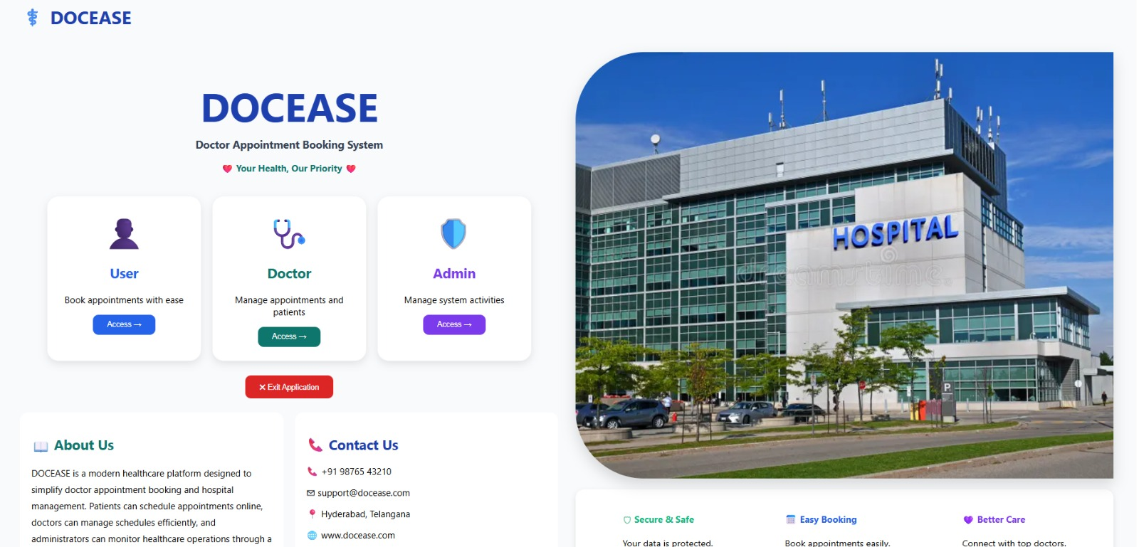
Fig. 14.1 – DOCEASE Home page with User / Doctor / Admin access cards
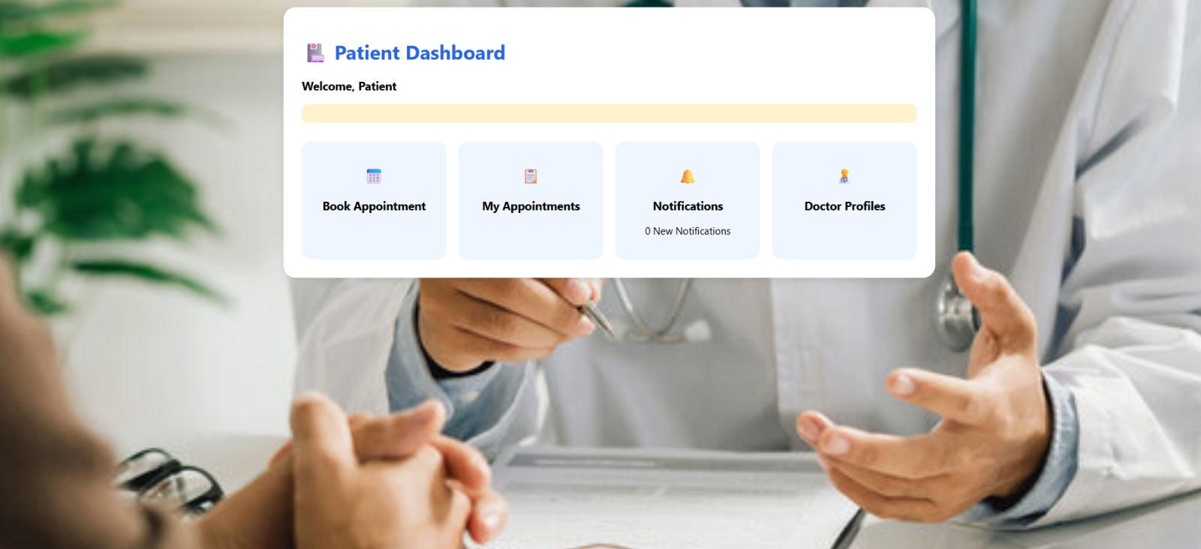
Fig. 14.2 – Patient Dashboard with Book Appointment, My Appointments, Notifications and Doctor Profiles
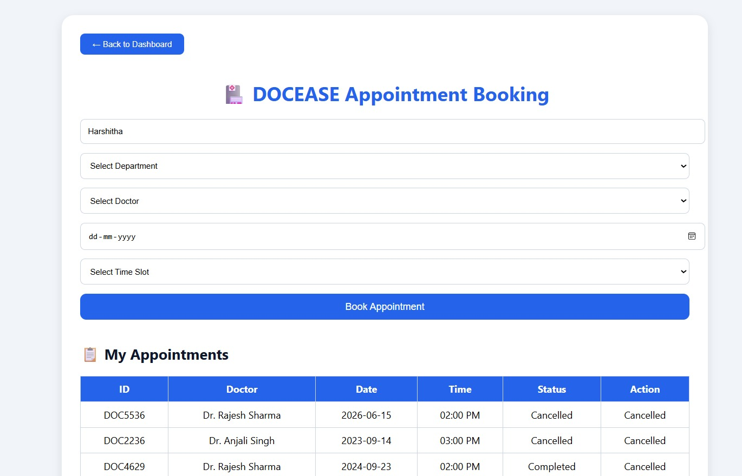
Fig. 14.3 – Appointment Booking form with My Appointments history table
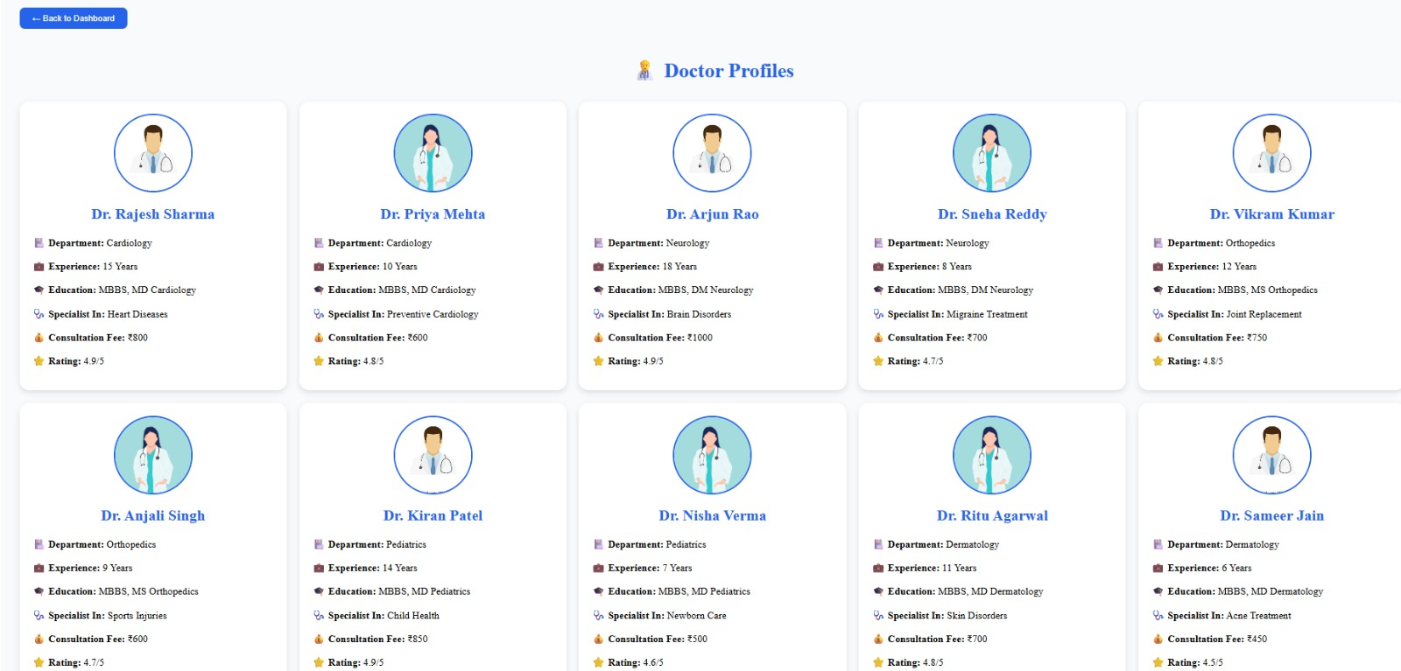
Fig. 14.4 – Doctor Profiles directory showing department, experience, fee and rating
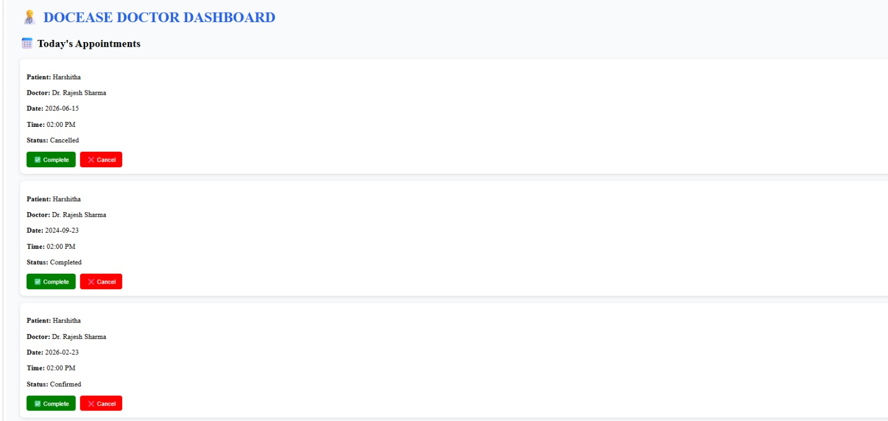
Fig. 14.5 – Doctor Dashboard with Today’s Appointments and Complete / Cancel actions
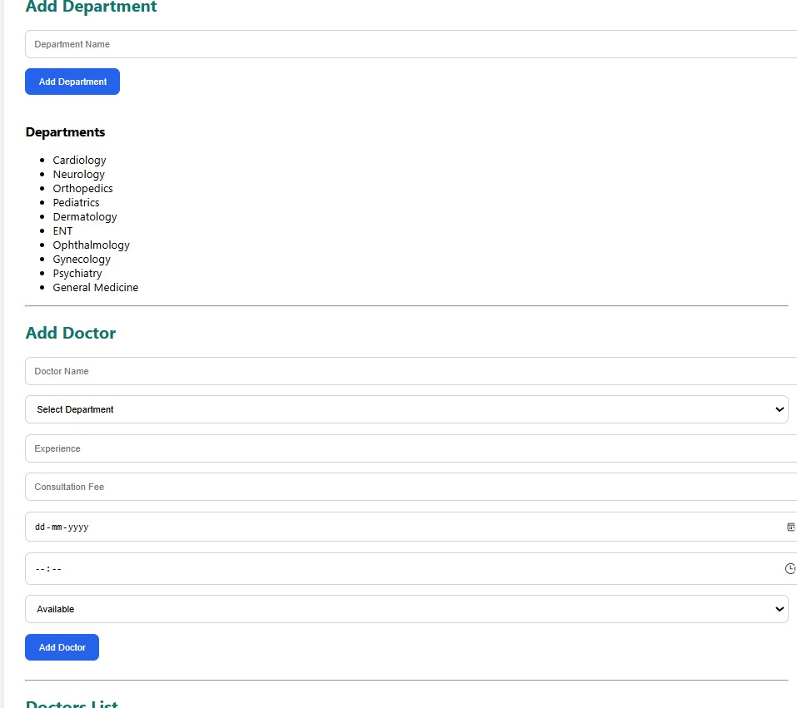
Fig. 14.6 – Admin – Add Department and Add Doctor forms with live Departments list
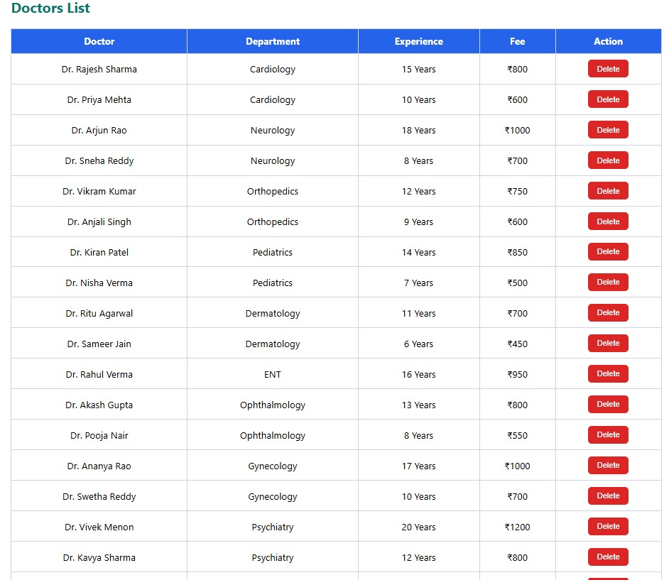
Fig. 14.7 – Admin – Doctors List with department, experience, fee and Delete action
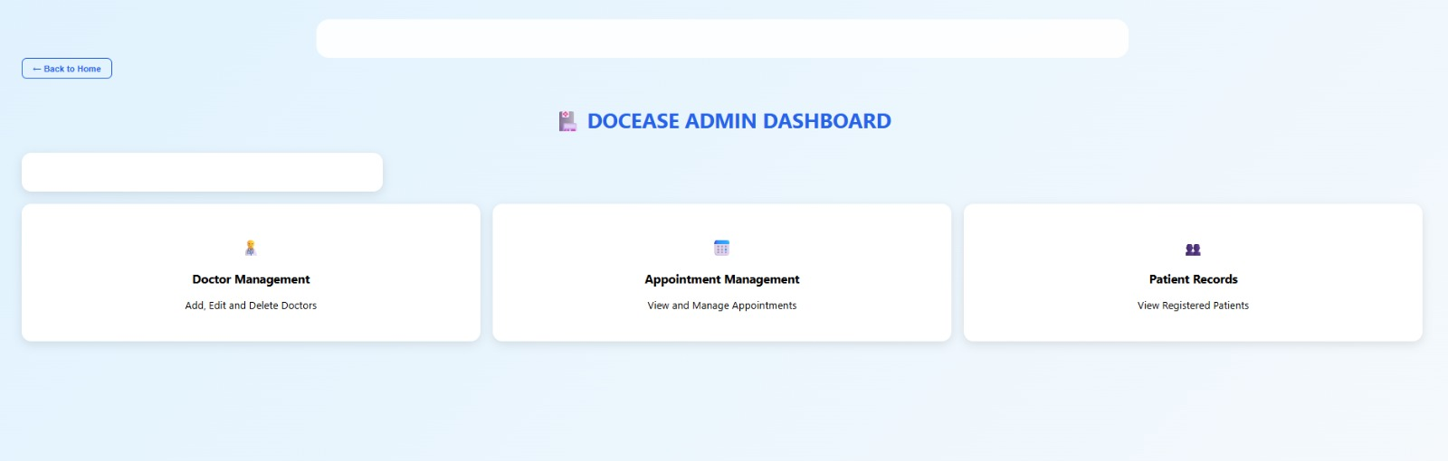
Fig. 14.8 – Admin Dashboard with Doctor Management, Appointment Management and Patient Records
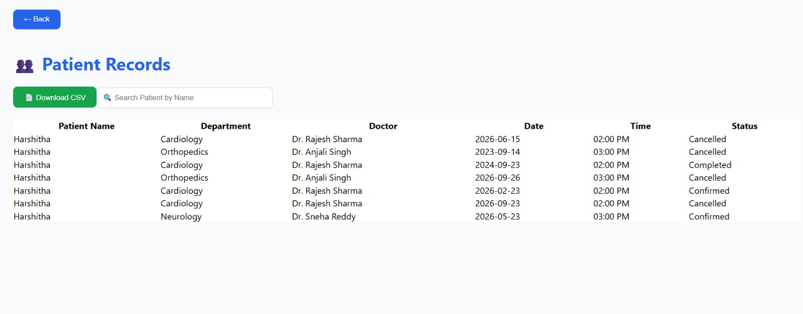
Fig. 14.9 – Admin – Patient Records with search and Download CSV

Sample Code Snippets
The following screenshots show representative sections of the DOCEASE source code, taken directly from the project's Visual Studio Code workspace.
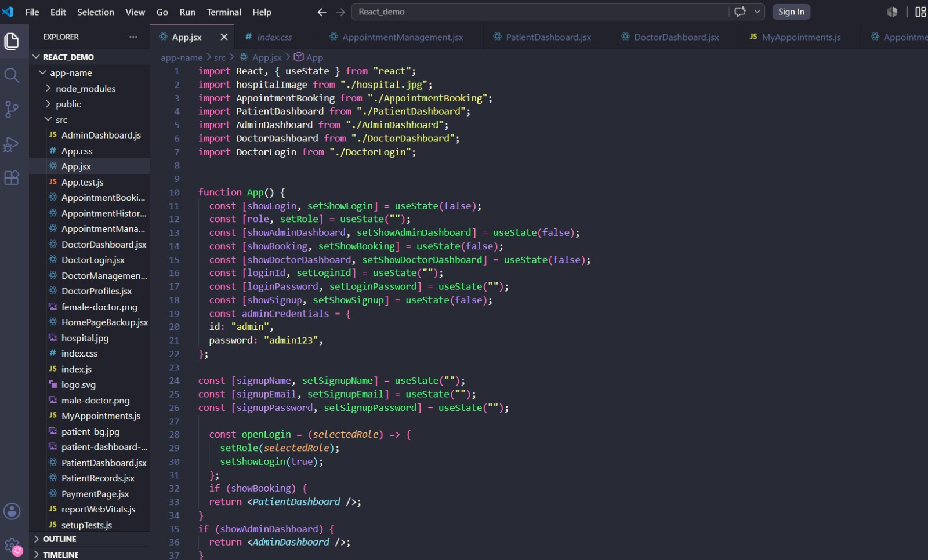
Fig. 14.10 – App.jsx – root component state and dashboard routing logic
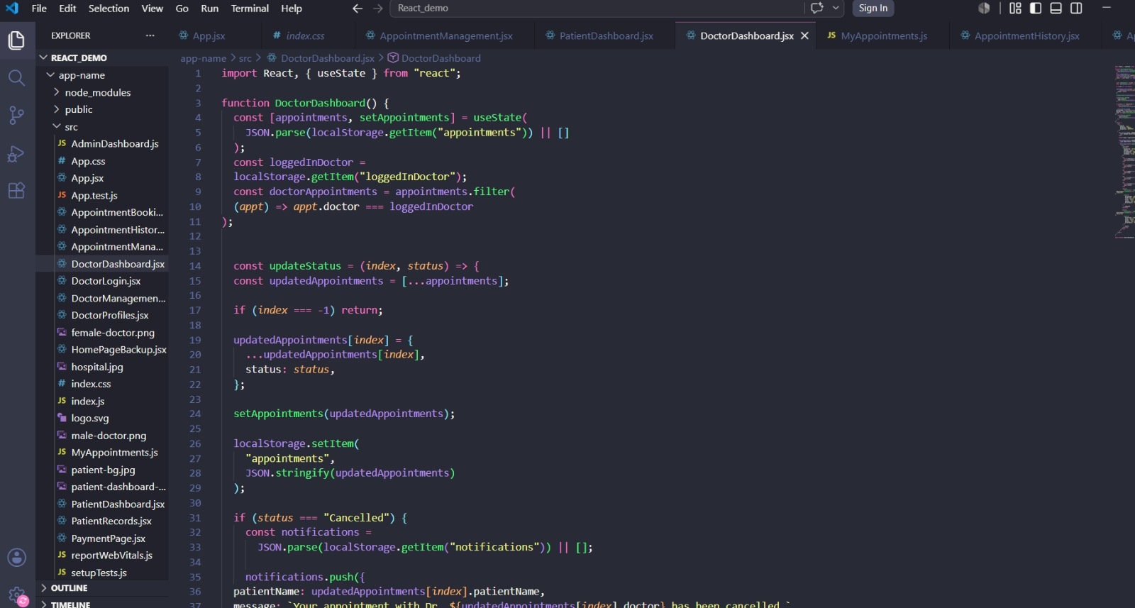
Fig. 14.11 – DoctorDashboard.jsx – filtering appointments and updateStatus() logic
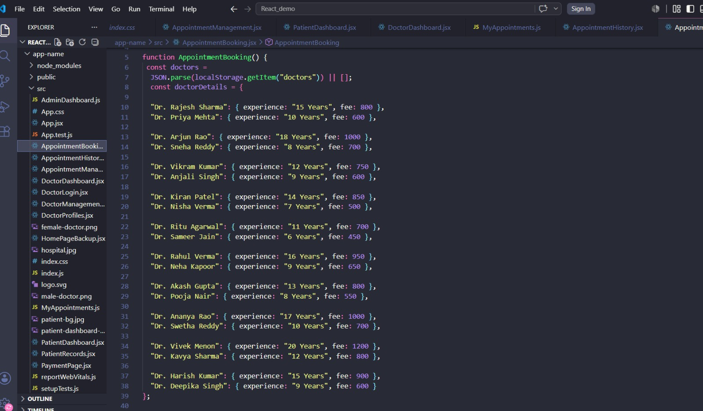
Fig. 14.12 – AppointmentBooking.jsx – doctor and department data used for booking

Installation / Setup Instructions
DOCEASE is built using React.js and can be set up on any machine with Node.js and npm installed, following these steps:
- Ensure Node.js (v18 LTS or later) and npm are installed on your system.
- Download or clone the DOCEASE project folder (app-name) to your local computer.
- Open the project folder in Visual Studio Code (or any preferred code editor).
- Open a terminal inside the project folder and run: npm install — this installs all required dependencies (React, react-dom, react-scripts, etc.).
- Run: npm start — this launches the development server and automatically opens the application in your default browser at http://localhost:3000.
- To build a production-ready version of the app, run: npm run build — this generates an optimised static bundle inside the build/ folder, ready for deployment to any static-hosting platform.
No external database server or API keys are required to run DOCEASE in its current form, since all application data is stored locally in the browser via localStorage, making the project fully self-contained and ideal for classroom demonstrations and academic evaluation.

User Manual / Guide
On opening DOCEASE, the user is presented with the Home page, which displays the DOCEASE logo, a short tagline, and three role-entry cards: User, Doctor and Admin. Selecting User allows a patient to log in or sign up; selecting Doctor opens a doctor-specific login; and selecting Admin opens an administrator login that uses fixed institutional credentials.
After logging in as a Patient, the user lands on the Patient Dashboard, where they can click Book Appointment to open the booking form — entering their name, choosing a department and doctor, selecting a date and time slot, and confirming the booking. The same dashboard's My Appointments card shows a complete history of the patient's bookings with current status, while Notifications alerts them to any cancellations made by a doctor, and Doctor Profiles lets them browse every registered doctor before booking.
After logging in as a Doctor, the user sees the Doctor Dashboard's Today's Appointments list, where each patient's appointment can be marked Complete once the consultation has taken place, or Cancel if it needs to be called off — the latter automatically notifying the patient.
After logging in as an Admin, the user reaches the Admin Dashboard, from which Doctor Management is used to add new departments and doctors and to remove doctors who are no longer active; Appointment Management provides a consolidated view of every booking in the system; and Patient Records allows the administrator to search for any patient by name and download the complete patient list as a CSV file for offline reporting.

Geo-Tag Photos with Guide
The following geo-tagged photographs were captured during the project review and guidance session at the K L (Deemed to be) University campus, Gajularamaram, Hyderabad, Telangana, India, confirming the in-person discussion of the DOCEASE project with the project guide.
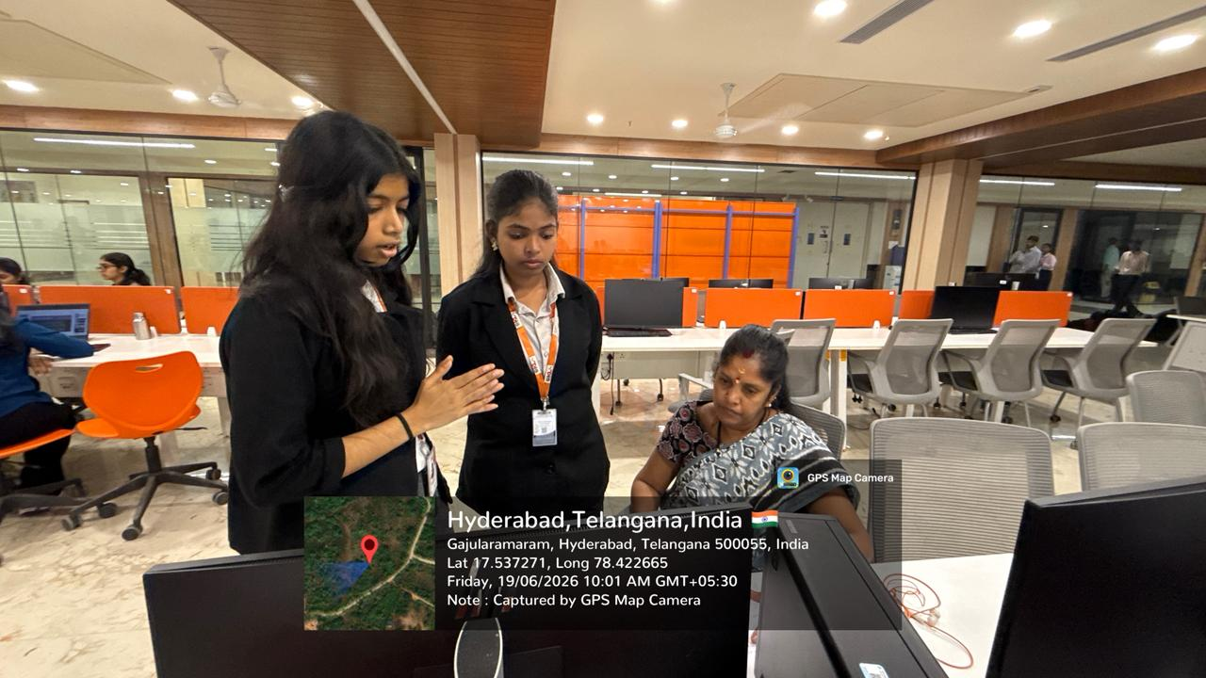
Fig. 14.13 – Project discussion with the guide, Hyderabad, Telangana (19/06/2026)
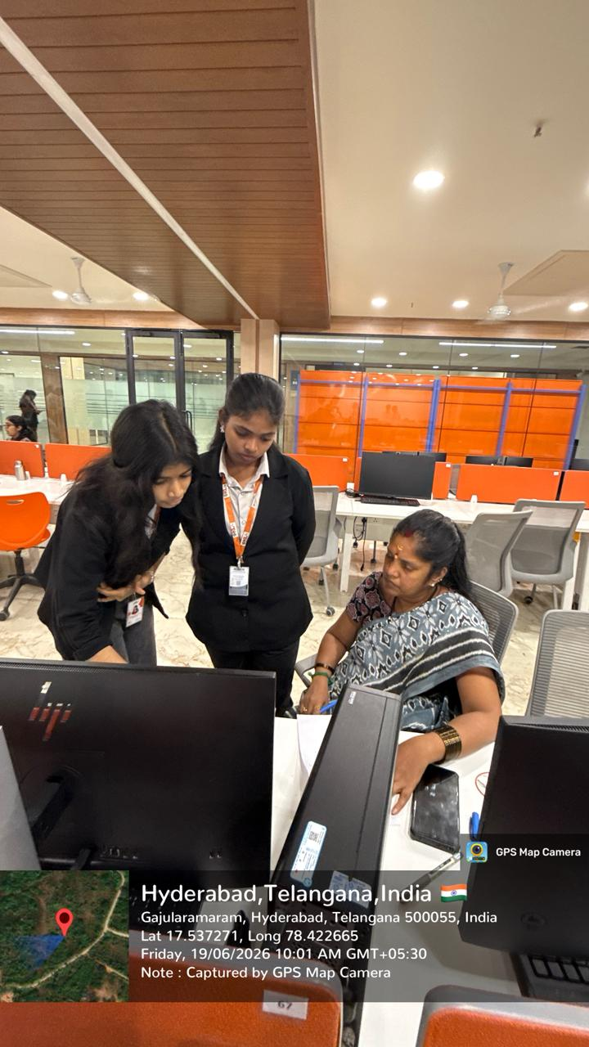
Fig. 14.14 – Project review session with the guide, Hyderabad, Telangana (19/06/2026)

